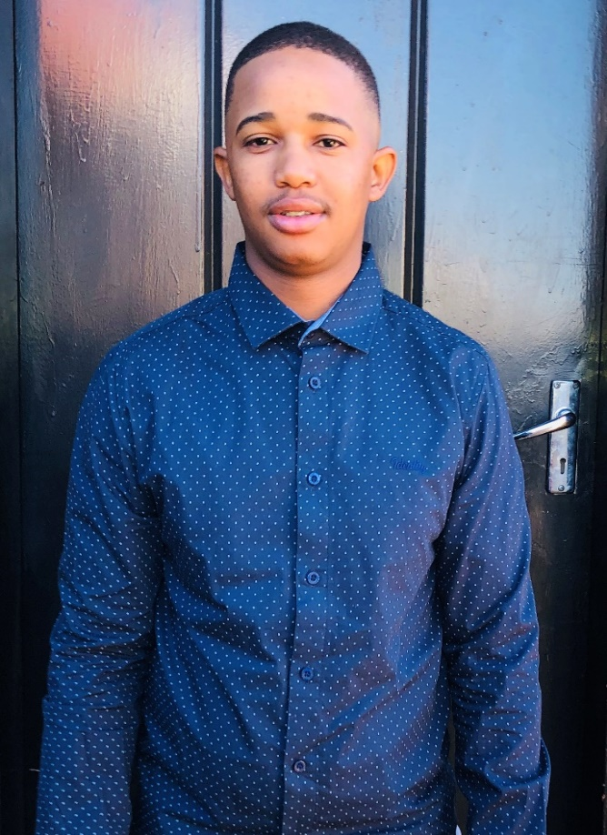

**Personal Info**

* Full names: Bennet Johannes
* Surname: Dhlamini
* Gender: Male
* Race: African
* Nationality: South African
* Country of Birth: South Africa
* Citizenship: South African
* ID number: 9811065338080
* Contact number: 0731175440
* Email: [bennetjdhlamini@gmail.com](mailto:bennetjdhlamini@gmail.com)

**Education**

* North West University (Vaal Triangle Campus)
* Degree – BSc in Information Technology
* Average: 69%
* Residensia Secondary School
* National Senior Certificate
* Average: 57%

**Development experience**

3 years

**Work experience**

Graduate/Entry level

**Skills**

* Programming (Java, JavaScript, C#, HTML, and CSS)
* Knowledge in Databases (MySQL, Microsoft SQL Server Management Studio, and MS Access), System analysis and design, Data analytics, Data structures and Algorithms, Operating Systems, and Computer Networks (Cisco).
* Artificial Intelligence, Expert Systems, Decision Support Systems,
* Microsoft Office (Excel, Word, PowerPoint and Access), Communication skills (verbal and written), Creative problem solving, Critical Thinking, Mathematics and Statistics.
* Visual studio (.Net Core, ASP.NET CORE MVC and ASP.NET), Visual studio code, Node.js, React.js, and BlueJ
* Here is my GitHub link to my completed projects so far [BennetJDhlamini · GitHub](https://github.com/BennetJDhlamini/)

**Summary**

I’m an open, creative, motivated, adaptable, and responsible recent information technology (IT) graduate seeking for employment in the field of information technology. I lead myself and others to make a difference and deliver results in a responsible, authentic, resilient, inclusive and passionate manner. I apply a range of technical capabilities to deliver quality and value. I build relationships of high value which are genuine and rooted in trust.

**References**

NWU (Admin) – 016 910 3111

Residensia Secondary School – 016 988 1469